Application built with 5.1 linked to 5.1 DLL’s.
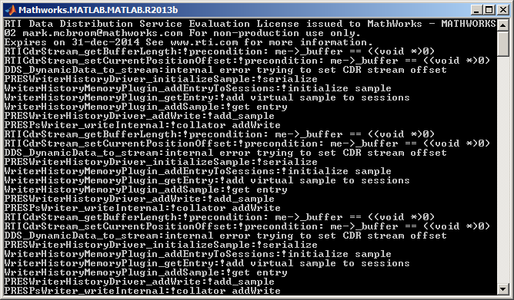

Application built with 5.0 and linked to 5.1 DLL’s. Same error.
